Please watch our installation videos at
www.CoversAndCamo.com/Installation
These instructions will be helpful if you cannot watch our videos.
Dura/Camo/Sim-Leather Front Row
Install time: 1 ½ - 2 hours
Any questions contact: (435) 789-2270
As a general rule, we recommend that you start from the middle and work out, top and work down, and front working to the back.
Removing the Headrests
*If your vehicle does not have removable headrests, skip to “Installing the Console”.

- If your vehicle is a Chevy/GMC, you will need a pin (ex. finish nail or paper clip) that you can push through the little holes to release the lever while you complete step 2. See examples below.
Chevy/GMC Dodge
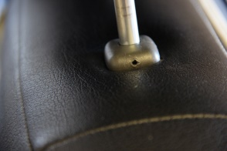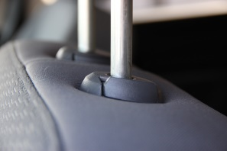
- In order to remove the headrests, you will need to pull up the headrest while pressing the release button near the headrest posts. Some vehicles only have one button while others have one per post. Every removable headrest will have a button or release mechanism.

Installing the Console
*If you don’t have a Console/Console lid to put on, skip to “Installing Bucket Backrests”.

- We recommend working top down. Besides the headrests, the console is usually the smallest pieces.
- You will be able to distinguish which pieces go to their respectable places by looking at their shape and size. Most pieces will have hook and loop Velcro that will help you as you attach them to their proper places.
Unclipping the plastic clips that hold the bottom flap
*If your vehicle is 2010 or newer it could have these flaps. If it does not have a hard plastic backing or flap in the back under the bottom cushion, skip to “Installing the Bucket Backrests”. See examples below.
Clipped Unclipped
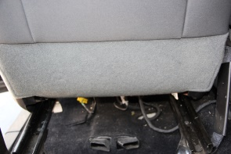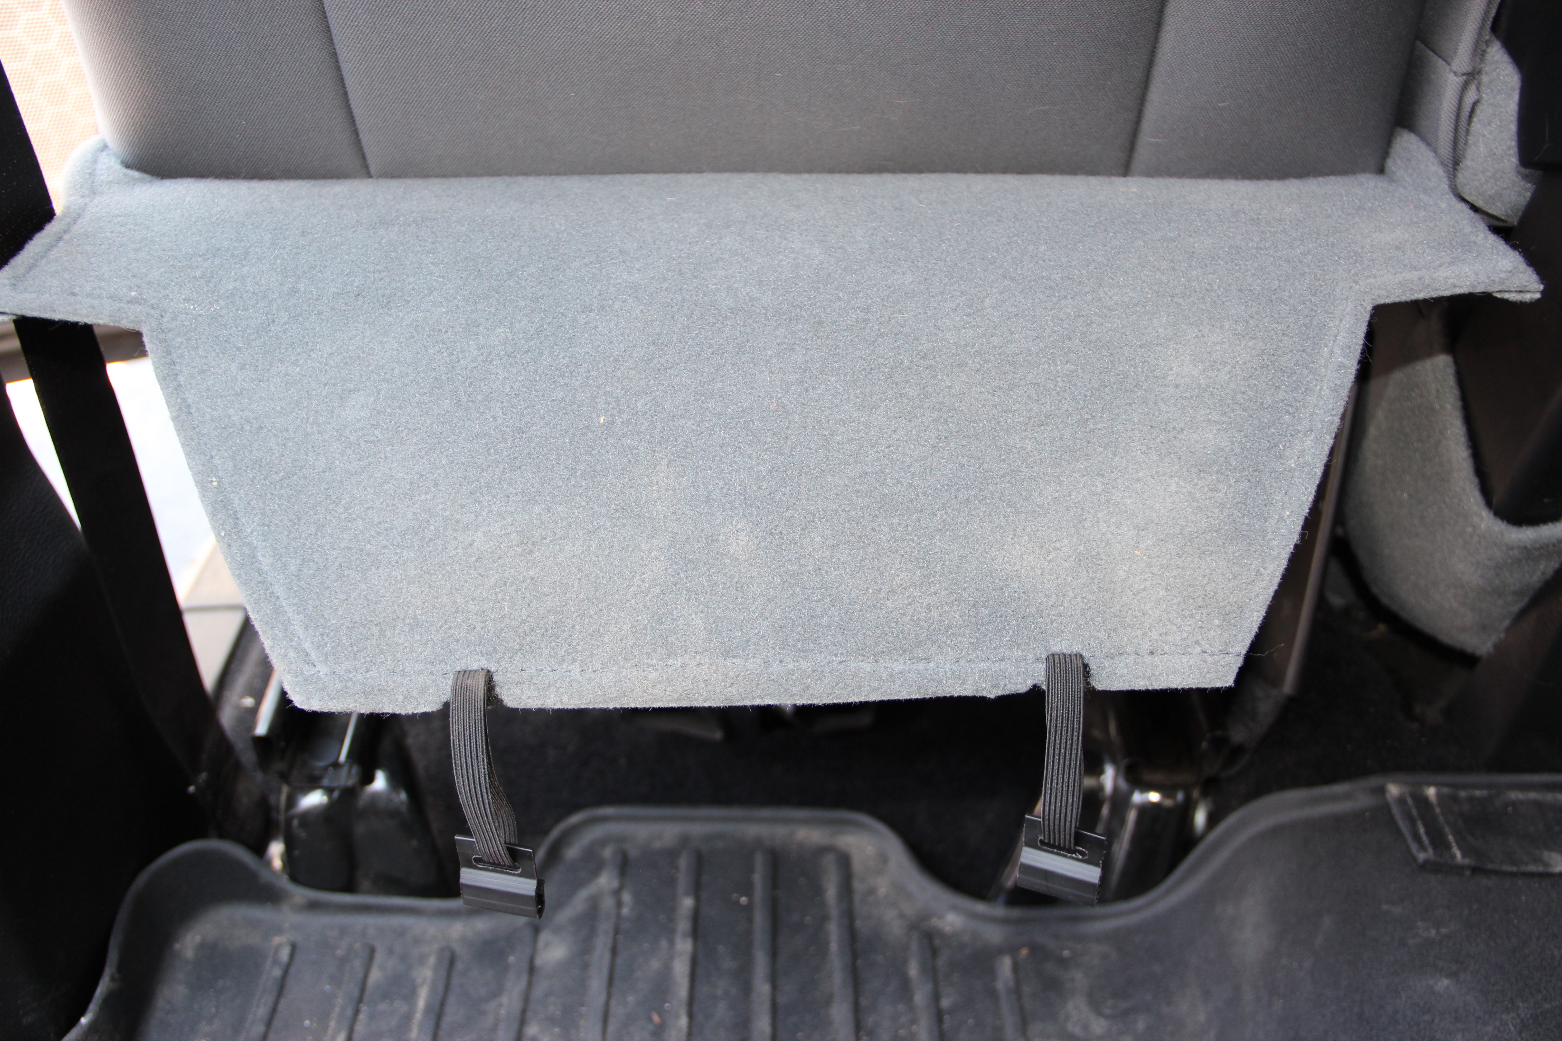
- Look or feel below the front bucket seat cushions in the rear. You should see/feel two elastic bands that are both sewn to the plastic flap connected to plastic clips which are clipped to the metal support springs for the seat. There should be two for each bucket seat.
- Once you have located these plastic clips push them slightly forward and down. This should release the clips from the springs.
- Flip the plastic flap up. This will give you access to the opening between the backrest and the bottom seat.

Installing the Bucket Backrests
- If you have Side Mounted Air Bags there will be Velcro on the outer side of the seat cover for the air bag to deploy. (There will be a tag and mostly for models 2010+) See examples below
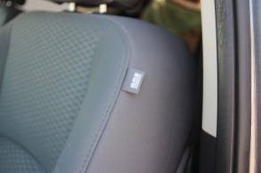
- Fold the backrests up 1/2 of the way.
- Slide the backrests down as far as you can, then roll them downward the rest of the way. If you have rear pockets, be careful that you don’t have your hand in the rear pocket as you are pulling down and rolling them.
- If you have the Velcro on the outer sides for your airbags, connect these together by placing the hook on the loop.
- Once the cover is on, feed the front flap through the space between the backrest and bottom seat. Pull as tight as you can, making sure it is not wrinkled.
- If you have hook Velcro, connect it to the flap already pushed through while keeping the cover tight. If you have elastic loops you will need to secure the bottom bucket seat cover (“Installing the Bottom Bucket Seats”) first . Secure the loops from the backrest cover to the metal support springs underneath the seat.
Installing the Bottom Bucket Seats
- Place the bottom seat cushion cover on the bottom seat and position it into place. You will be able to distinguish the driver seat cover from the passenger by distinct markings such as an opening for the seat belts, electronic controls, pockets, holsters, etc. If neither of these are present, look at the sides. Typically the side that is shorter will tuck into the plastic trim on the outer side of the seat.
- Connect the Velcro on the back of the seat cushion to the carpet on the bottom backside of the original seat bottom upholstery. If there is a strap in the middle with a buckle on the same side as the hook Velcro, you will need to loop the strap around one of the metal springs underneath the original seat and back to the buckle then secure it tightly.
- Connect the straps that run front to back, or on some vehicles back to front, to the lined up buckles.
- Secure any other Velcro flaps and then tie the string that is connected from each side together. Make sure to be careful that the string is not lying across any sharp metal as this will fray it and/or cut it. Move to “Installing the Headrests” unless your backrests have elastic band loops. If so continue to 5.
- Connect elastic band loops on the side that you had to push between the backrest and seat bottom (the loops that are connected to the front of the backrest). Secure these as tight as possible to a metal spring underneath the seat cushion.
- Drop down the plastic flap and secure the plastic hooks to their original positions.
- Repeat step 5 by connecting the remaining loops from the backside of the backrest.
- Do the same to the other side.
Installing the Headrests
- We recommend installing the headrests on the floor. Because they have a tendency to flop around, we suggest kneeling on the ground with a padded object to provide upper leverage.
- Fold the headrest cover half way up. Fit it on as far as possible, roll it on the rest of the way by adjusting a little on each corner, working your way around.
- Compressing the headrests as well as heating the headrest covers with a hair dryer can be helpful on some applications.
- Use the plastic tool provided to tuck the seat cover under the trim on the headrest posts caps. (You may need to make several very small cuts to allow in getting the cover tucked under the headrest post caps.)
Congratulations on installing your front row custom seat covers!
Using the accompanied form please write us a review of how you’re enjoying your new custom seat covers. Thanks!
Please watch our installation videos at
www.CoversAndCamo.com/Installation
These instructions will be helpful if you cannot watch our videos.

Installation Instructions
Dura/Camo/Sim-Leather Rear Row
Install time: 1 - 1 ½ hours
Any questions contact: (435) 789-2270
*After the headrests have been removed you can start on the rear row. It is very similar to the front row.
**If you don’t have a middle armrest skip to step 2.

- Position the armrest/cup holder on first by slipping it on and connecting the Velcro in the back.
- Lay the seat cover on the backrest and line up the cover up with the seat. If the seat has headrest use the holes for the headrest post caps to help get this in line.
- Drop the straps behind the backrest. Start with the seat bottom folded up. Push the straps down about ¼ of the way. As you angle the seat bottom down this should allow the straps to drop the rest of the way. You may need to do this a few times to get the straps all the way down.
- Feed the straps through the buckles. You may need to lay on your back and angle the bottom seat cushion up partway to allow room for your arm to pull the straps tight.
- Repeat Steps 2-4 for the other side if you have a split bench (60/40 split).
- If there are two elastic bands on the outer sides of the backrest, connect the two together or tie them tight to one of the Nylon straps, whichever is easier. If you have Velcro on the back, pull tight and connect the hook to the flap.
- Place the covers for the bottoms on the seat and line them up. Push the back of the cover through the opening between the backrest and bottom cushion. You might need to angle the bottom or backrest seat to give more room for your hand.
- Weave the straps through the lined up buckles, tightening them to a snug fit, and connect any Velcro flaps to carpet.
- Tie the string together.
- When installing the headrests we recommend installing them on the floor. Because they have a tendency to flop around, we suggest kneeling on the ground with a padded object to provide upper leverage.
- Fold the headrest cover half way up. Fit it on as far as possible, roll it on the rest of the way by adjusting a little on each corner, working your way around.
- Compressing the headrests as well as heating the headrest covers with a hair dryer can be helpful in some applications.
- Use the plastic tool provided to tuck the seat cover under the trim on the headrest posts caps. (You may need to make several very small cuts to allow in getting the cover tucked under the headrest post caps.)

Congratulations on installing your rear row custom seat covers!
Using the accompanied form please write us a review of how you’re enjoying your new custom seat covers. Thanks!

